The Virgin Earth Challenge
The Challenge Checklist

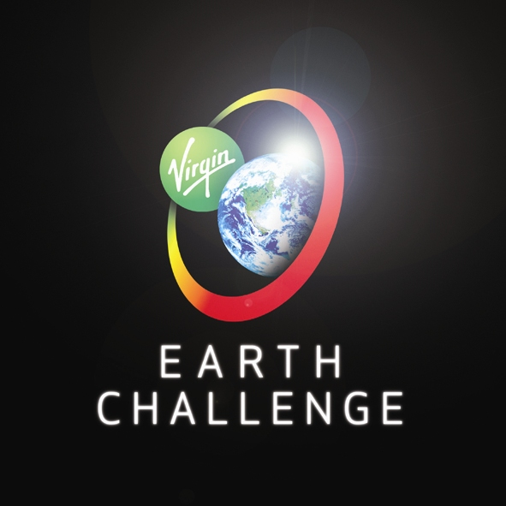 | Date: | 1-3-2010
 | Name of Primary Contact: | Tylan Peterson
 | Participation Number:
(to be filled out by the
Virgin Earth Challenge Office)
The Challenge Checklist is to help applicants provide the right information and data for the judges to assess their entry. The Checklist also acts to help entrants confirm whether their design is suitable to enter the Virgin Earth Challenge. Please complete all questions that are relevant to your design. Please note that cells will expand to allow for longer answers.

Any Checklist that does not answer “Yes” to both Questions 9 and 10 will not be reviewed by the judges. Applicants are advised to send additional material alongside the Checklist. Please refer to the Assessment Criteria (Clause 3.1) in the Terms and Conditions to find out what additional material is required. However the judges will first assess the Checklist and if the design is not found to fulfil the required criteria no additional material will be assessed.
Please fill out this Checklist electronically and not by hand. Then print out the Checklist and make sure each member of your team signs it to confirm that they have read and agreed to the Terms and Conditions of the Virgin Earth Challenge. If you have not read the Terms and Conditions you can find them at www.virginearth.com. This requirement of each member completing and signing does not apply to those entering as an academic establishment or a company.
Please send us the completed and signed Checklist. This can be submitted in writing by post (recorded delivery recommended) or by hand to: Virgin Earth Challenge, The School House, 50 Brook Green, London, W6 7RR, United Kingdom. Alternatively you may scan the Checklist and email it (in 10MB chunks) to: earth.challenge@virgin.co.uk

GOOD LUCK!

Contact Details
1) | Name of Entry: | Ozone Restoration Project
2) | Name of applicant(s): | 1: Tylan Peterson |  | 4:
 |  | 2: |  | 5:
 |  | 3: |  | 6:
 | Name of primary contact: | Tylan Peterson
3) | Address of primary contact: | Tylan Peterson  149 Spanish Moss Place  Camarillo Calif.  USA 93010
4) | Telephone no of primary contact: | 805-484-4925
5) | Email address of primary contact: | tyzone@roadrunner.com
6) | Principal country of application: | USA
7) | How did you hear about the prize: | News Paper
8) | How are you entering: | Individual
 |  | Business
 |  | Academic Institution
 |  | Other (Please Specify):
9) | I have read and agreed to the Terms and Conditions of the Virgin Earth Challenge. | Yes | Please note that we are only able to accept entries from Entrants who have read and agreed to the Terms and Conditions and ticked the Yes box for Question 9.

Design Categories
10) | Does your technology sequester greenhouse gases (GHGs) from the atmosphere? | Yes | If you have answered ‘NO’ to question 10 then I am afraid that the Virgin Earth Challenge only deals with applications that sequester GHGs from the atmosphere and your design is not eligible.
10) |  | No
11) | Does your technology create renewable or low carbon energy? | Yes
11) | Does your technology create renewable or low carbon energy? | No
12) | Does your technology prevent the emissions of GHGs? | Yes
12) | Does your technology prevent the emissions of GHGs? | No
13) | Which of the below categories does your technology fit into? | Avoided Deforestation or REDD |  |  | Carbonates
 |  | Reforestation or Afforestation |  |  | Algae
 |  | Biochar |  |  | Oceans
 |  | Machine |  |  | Biochemistry
Other
(Please Specify):

Design Description
14) | Please provide an abstract of how your design captures GHGs from the atmosphere and sequesters them.
 | My design is a lighter then air balloon craft and will use helium gas for lift.The craft will ascend to roughly 75000 feet and will convert liquid oxygen to ozone. Each flight time cycle will last 4 to 10 days. Every flight will disperse 2000 gallons of liquid oxygen converted to ozone. The ozone that is created will cover an estimated 50 square miles. The ozone parts ppm is hoped to be 10 to15 ppm more then twice the normal count.
15) | Describe in more detail how your design captures GHGs from the atmosphere. | NA
16) | How would you quantify how much GHG your design had sequestered? | NA
17) | Which GHGs does your design sequester? | NA
18) | Describe in more detail how your design sequesters GHGs. | NA
19) | Once your design has removed GHGs from the atmosphere, how does it stabilise the GHGs, to stop them being re-released into the atmosphere? | NA
Research
20) | How long have you been researching your design? | 15 Years
21) | Explain at what stage you are in researching your design? | concept, research and planning are done.
22) | Have you finished the research stage of your design? | Yes
22) | Have you finished the research stage of your design? | No
23) | If not, what research do you have yet to do? | none
24) | Do you have the resources to do that research or are you looking for funding? | NA
25) | When do you foresee your research being finished? | NA
26) | Do you have a prototype of your design, which the assessment team could visit and see working? | Yes
26) |  | No
27) | Where is your prototype situated? | NA
Greenhouse Gas Numbers
28) | Describe what resources you'd require to sequester 1 tonne of carbon equivalents (for example in terms of power, machines and materials). | NA
29) | How much GHG could you realistically sequester on a yearly basis?  (Please state this in terms of carbon equivalents not CO₂ equivalents). | NA
30) | Explain the above figure and how you came by it. | NA
31) | How long would you estimate that GHG is sequestered for? | NA
32) | Does your design require energy? | Yes
32) | Does your design require energy? | No
33) | If so, what type of energy would it require? | Gas powered electric generator and propulsion system
34) | If so how much energy does your design require to remove 1 tonne of carbon equivalents? | NA
35) | Please explain the above figure. | NA
36) | What is the net cost or profit of your design to sequester 1 tonne of carbon equivalents?  (Please calculate this not including potential profits from carbon credits. Please give your answer in the units of USD ($) per tonne of carbon equivalents). | NA
37) | Please explain the above figure. | NA
Products
38) | What products does your design have?  (For example energy, waste, by-products) | Small amounts of co2
39) | How much of these products would you produce for each tonne of carbon equivalents sequestered? | NA
40) | What would you do with those products? | NA
41) | What is the commercial value of those products? | NA

Commercial Potential
42) |  | Explain how the design is commercially viable? | The global warming solution will have to be government funded.
43) |  | What would be needed to turn your design commercial? | Phase 1. We would need a place of business 10 aerospace engineers, 3 electctrical engineers, 4 research goffers, 3 secretarys and 2 directors. Phase 2 A small airport where we can do construction of the craft.
44) |  | Do you have a business plan? | Yes | see above
 |  | Do you have a business plan? | No | see above
Policy
45) | Explain the policy implications either complimenting or hindering your design. |  | My air craft will have to be FAA certified for commercial air space.
46) | Could you acquire carbon offset credits from the voluntary market? |  | NA
47) | Could you acquire carbon offset credits under the Clean Development Mechanism (CDM)? |  | NA
48) | Is your design an approved CDM methodology? |  | Yes
48) |  |  | No
49) | Do you have the intellectual property rights to your design? |  | Yes
49) |  |  | No
50) | Do you have the patent to your design? |  | Yes
50) |  |  | No

Background
51) | What is the academic and business background of the applicants? | I have 15 years of mechanical repair, I hold a 500 horse power  license in steam plant operation and an additional 10 years of  manufacturing of CNC machinery.
52) | Has your design originated out of work that you carried out at an academic institution, company or with a research grant, which might jeopardize the intellectual property rights of your design? | NO
53) | If so please provide more details. | NA
54) | How would you utilise the $25 million if you were to win the Virgin Earth Challenge? | I would need 5 million dollars to completely design of the ozone craft and about 7 million dollars more to complete the first two crafts. The more we build the less expensive they become. I would ask the U.S. government for the funding.
55) | What is the unique aspect you and/or your organisation brings or has brought to this field of technology? | Designing the frist high altitude long duration lighter then air ship, would enable us to generate ozone in the ozone layer and would also double as a science platform for the study of the outer atmosphere for long periods of time.

Your signature on this Agreement acknowledges that you:
- have read and understand the Virgin Earth Challenge Terms and Conditions Agreement and agree to comply with and be bound by them;
- are duly authorised to execute this Agreement on the entrant’s behalf;
- own all rights in and to your design entry;
- have submitted your own original work;
- are not in breach of any obligation of confidence;
- are not in violation of any third party rights or applicable laws; and
- have secured all rights and permissions necessary to submit the design entry and to exploit (or grant rights to exploit) the design anywhere in the Universe.

Signed (1) Signed (4)
……………………………………. …………………………………….
Date Date
…………………………………….. ……………………………………..

Signed (2) Signed (5)
……………………………………. …………………………………….
Date Date
…………………………………….. ……………………………………..

Signed (3) Signed (6)
……………………………………. …………………………………….
Date Date
…………………………………….. ……………………………………..

